Note: Native VLAN has on benefit.Because frames in the native VLAN aren’t tagged ,it’s more efficient,each frame is smaller so it allows the device to send more frames per second.

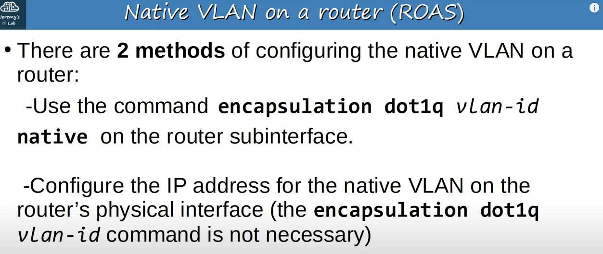
Ways of configuring native VLAN on a router.

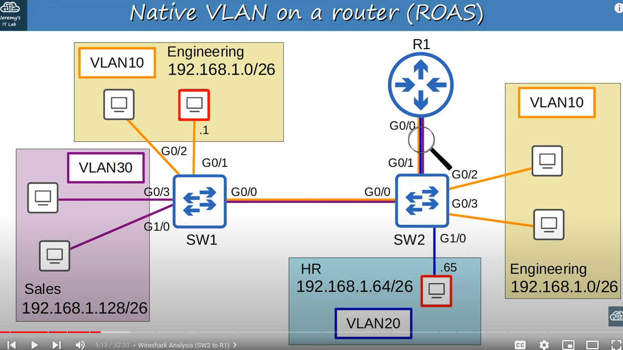
Network topology

Note: We already configured ‘encapsulation dot1q 10 native’ on G0/0.10 subinterface.Also we set native Vlans on switches to 10.And let’s look at the traffic between PCs in different VLANs(described in Note below) with this configurations

Note: PC in VLAN20 (192.168.1.65) sends traffic to PC in VLAN10(192.168.1.1).

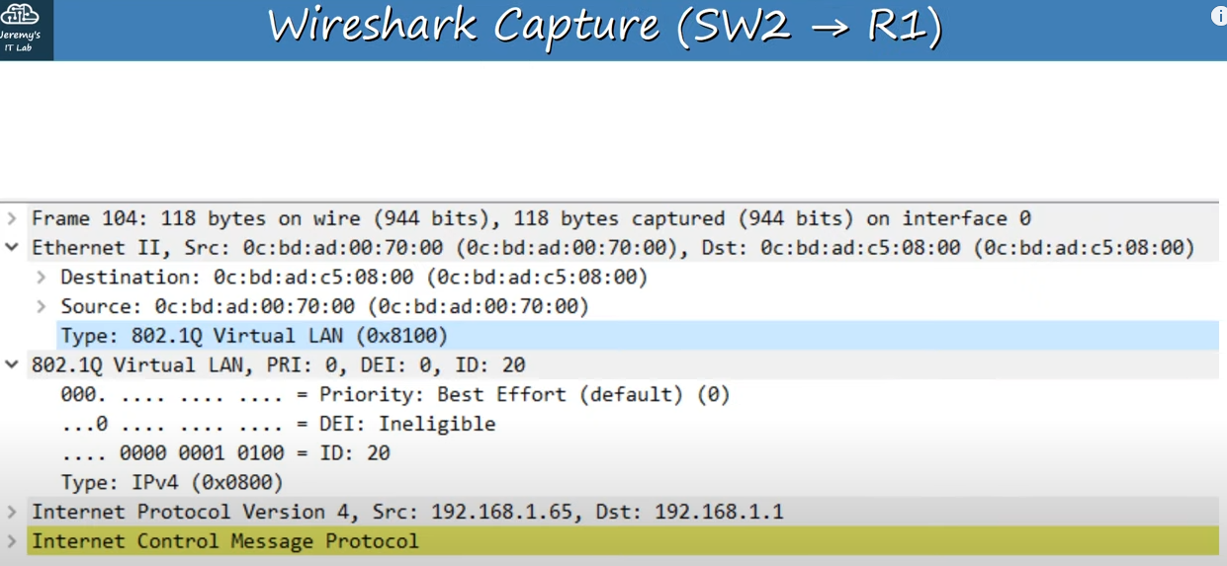
ICMP request from SW2 to R1

Note: PC in VLAN20 wants to send ICMP request to PC in VLAN10,so it sends ICMP request to SW2 .Then SW2 forwards it to R1.

Note: PCP(priority code point) is 0,so no special priority is given to this frame.
Note: DEI(Drop eligible indicator) is 0,so it won’t be dropped during times of network congestion
Note: Under DEI is VID .

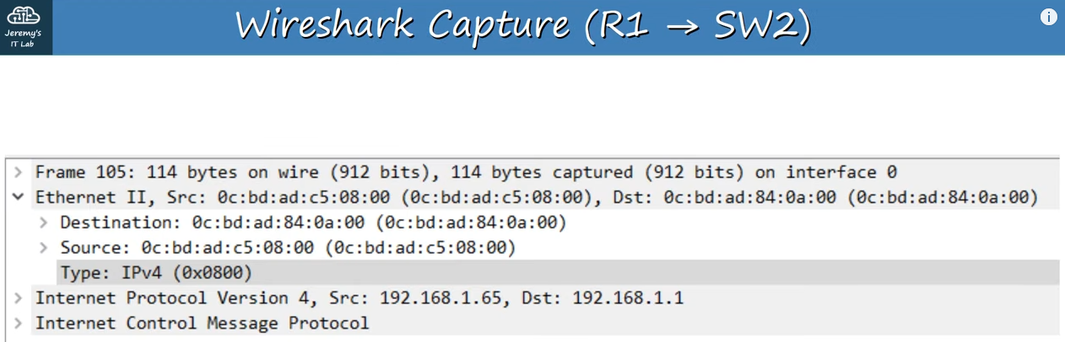
ICMP echo request(from R1 to SW2)

Note: R1 encapsulated the previous frame(ICMP request from SW2 to R1) with new ethernet header.But this new ethernet header does not have a dot1q tag. This is the native VLAN function at work.Both R1 and SW2 understand that untagged frames belong to VLAN10,so there is no need to tag each frame with dot1q.That ICMP request will continue to the destination,untagged all the way because VLAN10 is configured at the native VLAN on all devices.

Note: When PC(192.168.1.1) in VLAN10 sends the ICMP reply ,it will be untagged until it reaches R1,which will then tag it in VLAN20,ans send it back to the PC that sent the request.

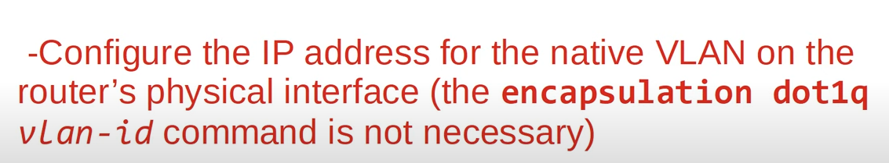
Second way of configuring native VLAN on a router

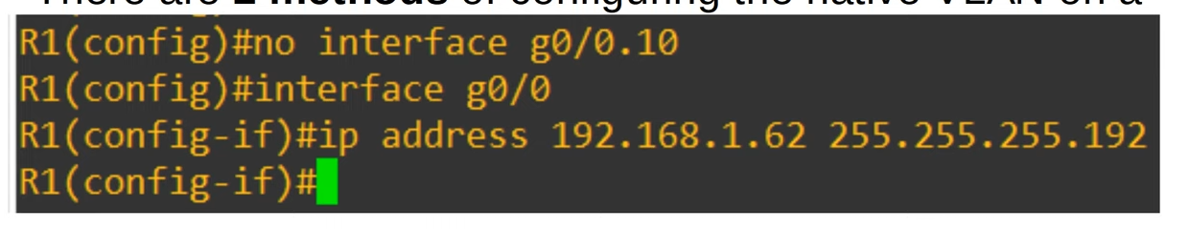
Deleting subinterface with ‘no <subinterface_name>’ and configuring native VLAN on a router with second way

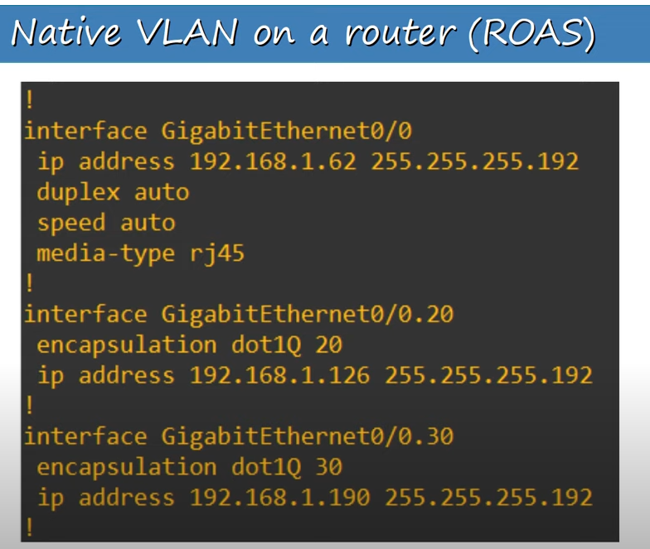
‘show running-config’ command’s output for g0/0 and it’s subinterfaces

Note: duplex,speed,media-type are on physical interface(g0/0) by default.

Note: The physical interface is configured normally with an IP address.Thiss will be used for the native VLAN, VLAN10.This will function just like in first way of configuring native VLAN on router,SW2 will send VLAN10 packets in untagged frames to R1,and R1 will send them in untagged frames also

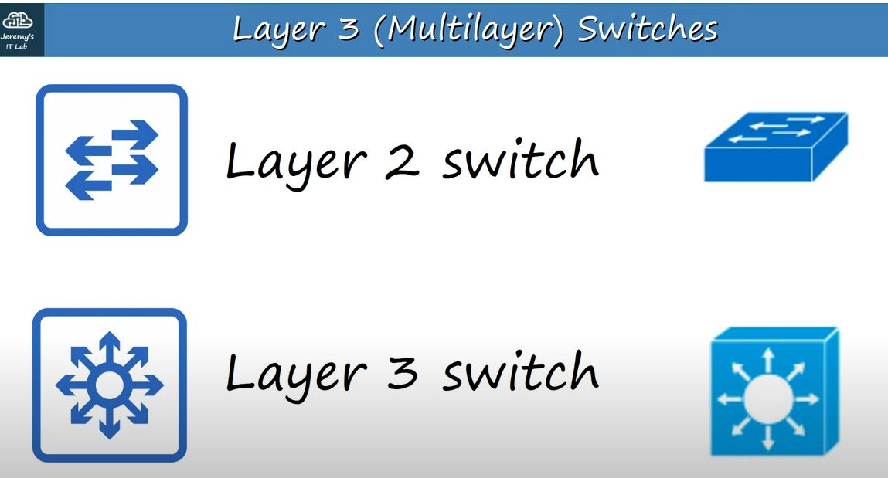
Layer 3(also known as Multilayer) and Layer 2 switches icons.(Cisco icons on the right)

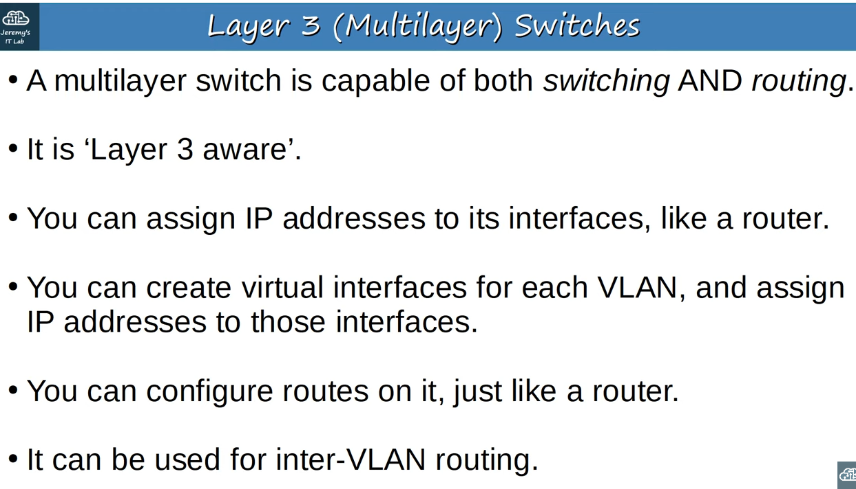
About Layer 3 switches

Note: A regular Layer 2 switch is not layer 3 aware.

Note: Previously we haven’t assigned any IP addresses to switches.With Layer3 switchs we can configure ‘routed ports’ which function like an interfce on a router.We can’t assign IP addresses to Layer 2 switches(but from indian youtube video,we can assign ip address to vlans).

Note: (continuing forth points) These are not separate physical interfaces,but virtual interfaces in the softwaare of the switch that can be used to route traffic at Layer 3.

Note (continuing last point)‘ROAS’ method of inter-VLAN is efficient in terms of the number of interfaces,just one,but in a busy network all of the traffic going to the router and back to the switch can cause network congestion.So in large networks,a multilayer switch is the preferred method of inter-VLAN routing.

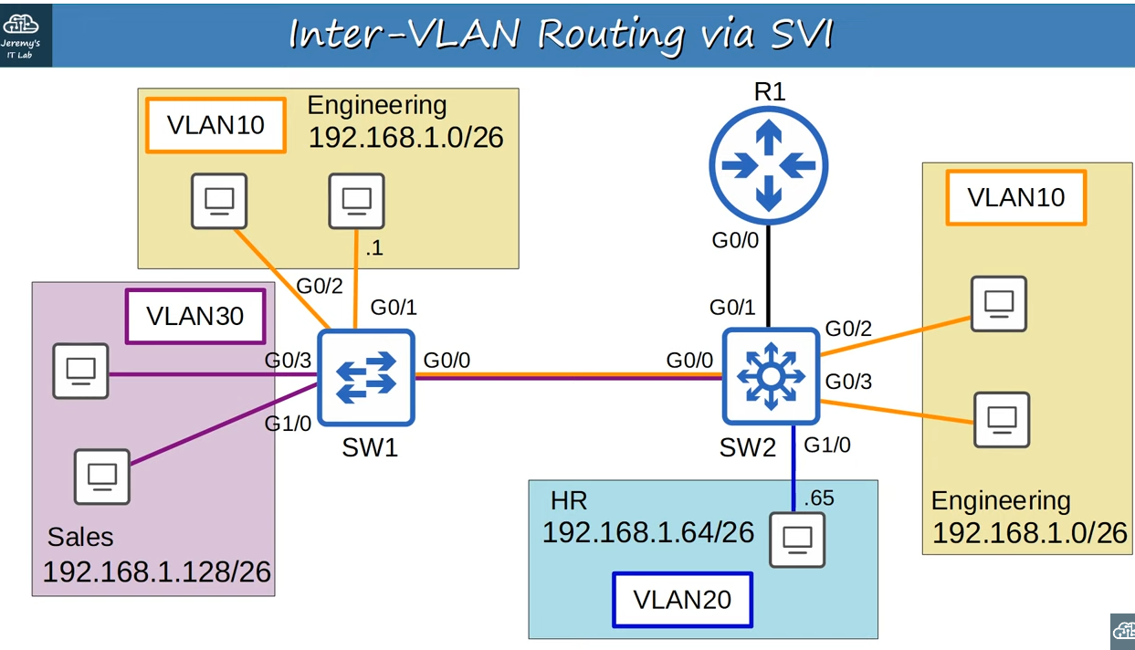
Network topology with replaced Layer 3 switch and point-to-point Layer3 link instead of trunk link between SW2 and R1.

Note: We will no longer run VLANs across point-to-point Layer 3 link between R1 and SW2.

Note: Now we will look at inter-VLAN routing on SW2.

Note: Because now SW2 is multilayer switch,it doesn’t have to send the traffic to R1 for inter-VLAN routing.It can do that with ‘Switch Virtual Interfaces’(SVI).

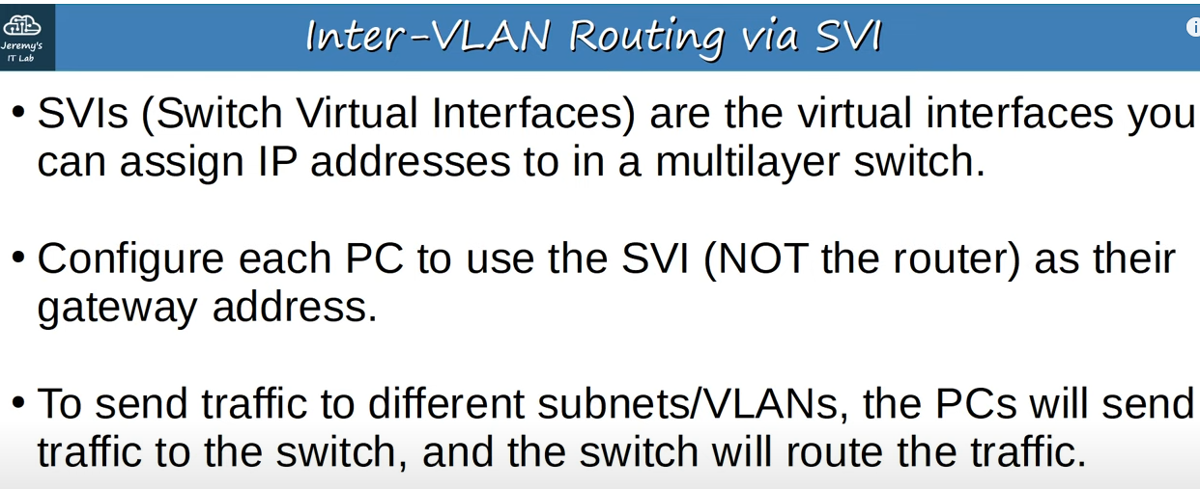
SVI

Note: When usin ‘ROAS’ the router was used as PC’s gateway.This time,we will use switch’s SVIs instead.

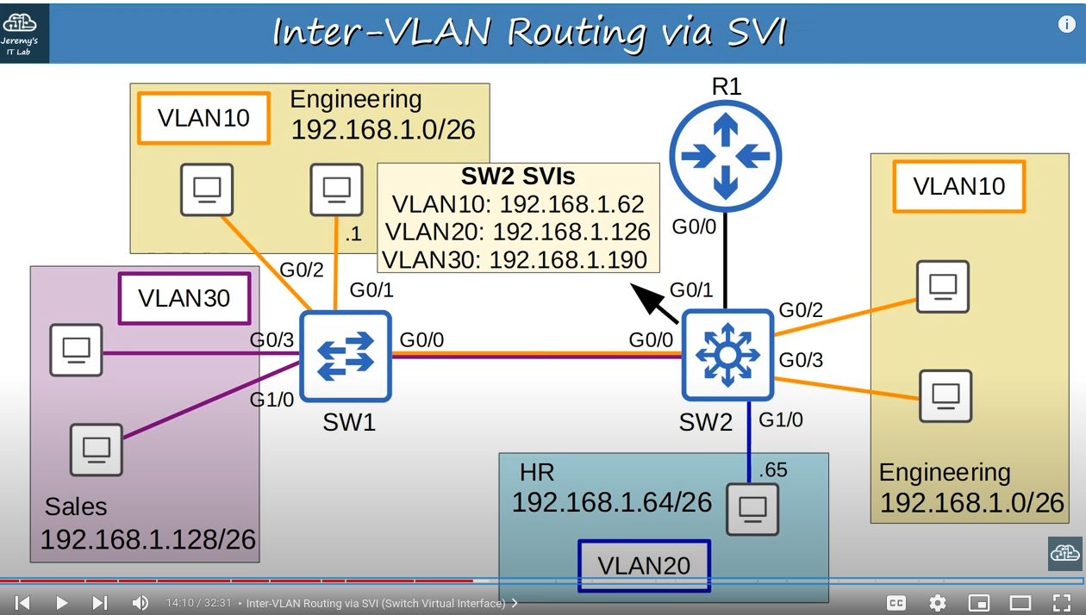
SVIs configured on SW2(same IP addresses as in the case of ROAS,when configuring R1’s IP addresses)

Note: We also configured IP addresses in yellow box as default gateways in PCs.

Note: Lets look at the traffic between PC in VLAN20 (192.168.1.65) and PC in VLAN10(192.168.1.1) in case of multilayer switch.The frame arrives at SW2.The destination is in the 192.168.1.0/26 subnet.SW2 now has its own routing table,so it looks up the destination in the routing table,and sees that the destination is connected to its VLAN10 SVI.So, the traffic is now routed to VLAN 10.If the SW2 doesn’t have the destination MAC address in its MAC address table,it will flood the frmae to all VLAN10 interfaces,but let’s assume it has already learned the MAC address,so it forwards it to SW1 over its trunk interface,tagged as VLAN10.SW1 then forwards it to the destination.
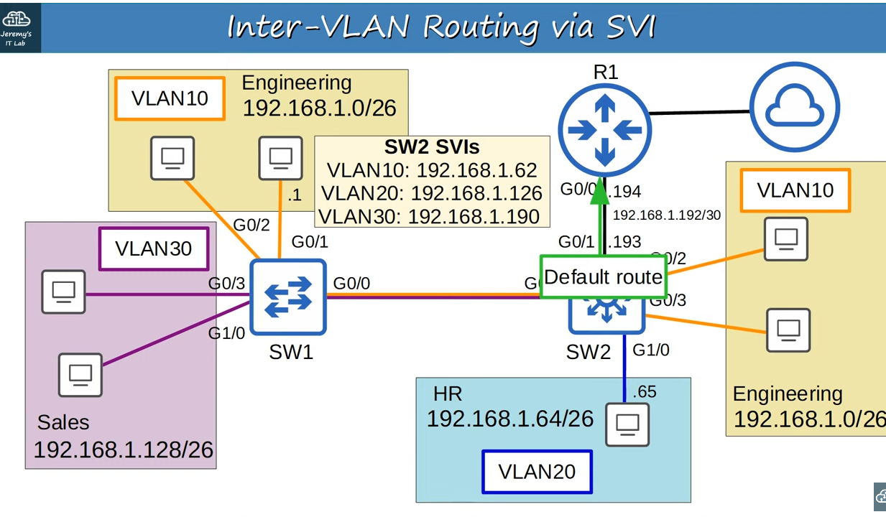
When hosts want to reach destinations outside of the LAN

Note: If hosts want to reach destinations outside of the LAN,for example to internet(cloud on image),because SW2 is their default gateway,any packets destined outside of their subnet will be sent to SW2.But our previous router on a stick configurations,for the connection between SW2 and R1 will no longer work.In addition to configuring virtual interfaces,SVIs,on multilayer switches,we can also configure their physical interfaces to operate like router interface,rather than switchport.So we can assign the subnet 192.168.1.192/30 for the point-to-point link between SW2 and R1.With IP addresses of R1’s and SW2’s interfaces as .194 and .193.Then we configure default route(on SW2) toward R1,so all traffic destined outside of the LAN will be sent to R1.

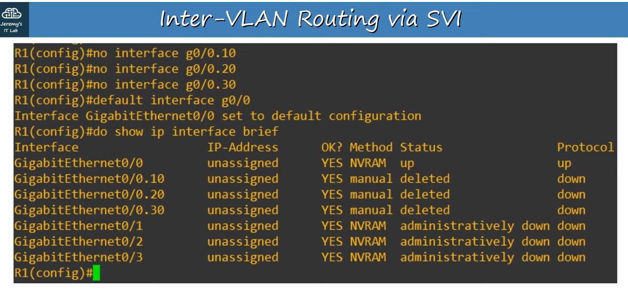
Configuring R1

Note: First we remove R1’s router on a stick configurations(removing subinterfaces) with ‘no <interface_name>’ command.Then we use ‘default’ command to reset G0/0 to it’s default settings.Status of subinterfaces says deleted.Although we have successfully deleted subinterfaces,they will remain here with a ‘deleted’ status unless we reload the router.

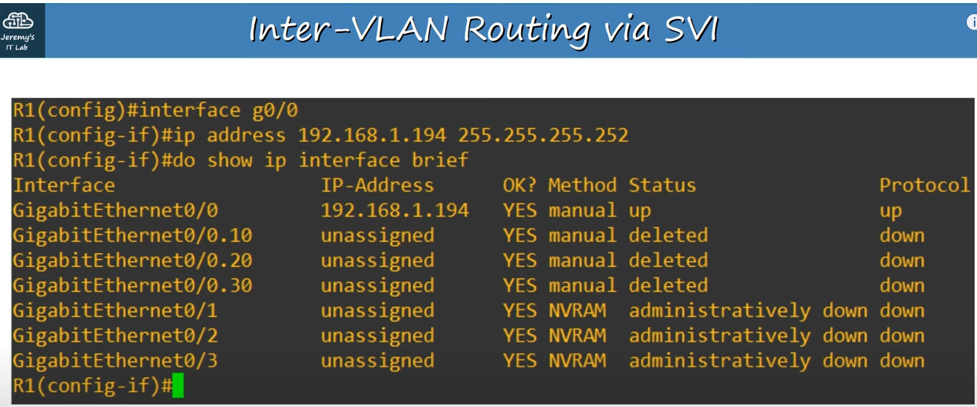
Configurations on R1(Configuring IP address)

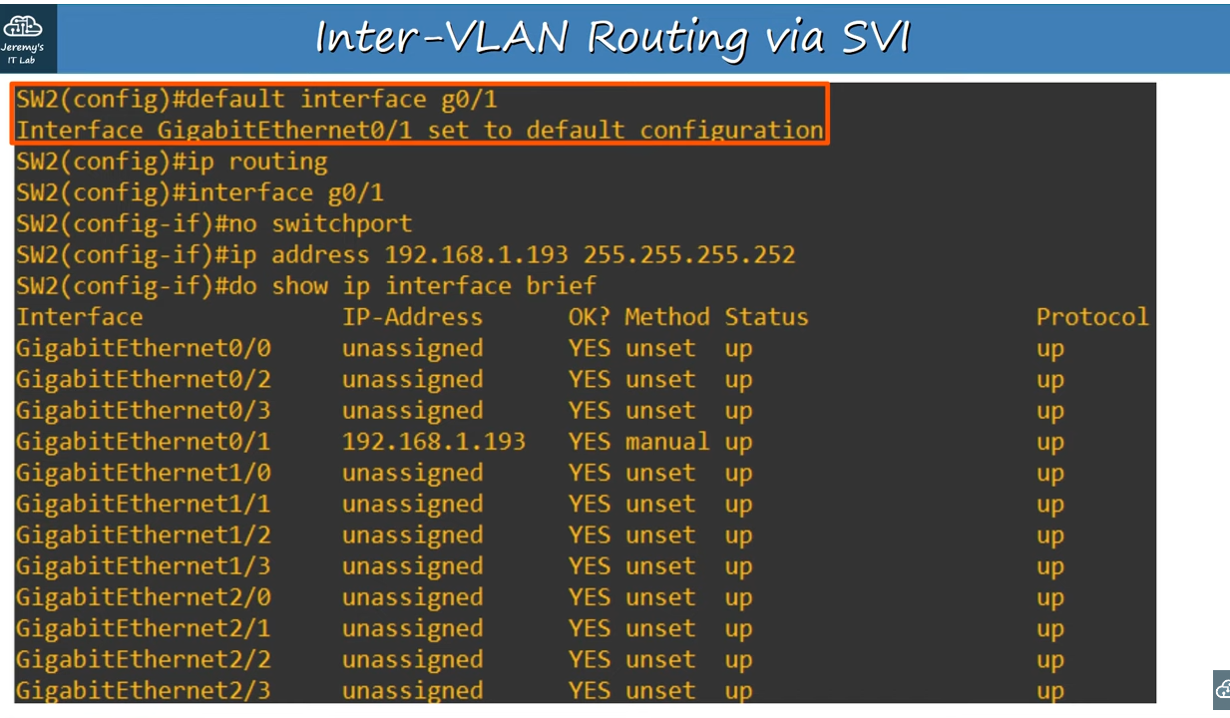
Switch configurations of point-to-point connection

Note: First we reset the G0/1 interface to its default setting with the ‘default interface <interface_name>’ command,because it was configured as a trunk for ROAS.

Note: ‘ip routing’ command enables Layer 3 routing on the switch,it lets it build its own routing table like a router.If we don’t write this command inter-VLAN routing won’t work.

Note: ‘no switchport’ command on the interface,changes the interface from a Layer 2 switchport to a Layer 3 routed port.Now we will be able to assign IP address to that interface.So we assign 192.198.1.193 IP address to it.
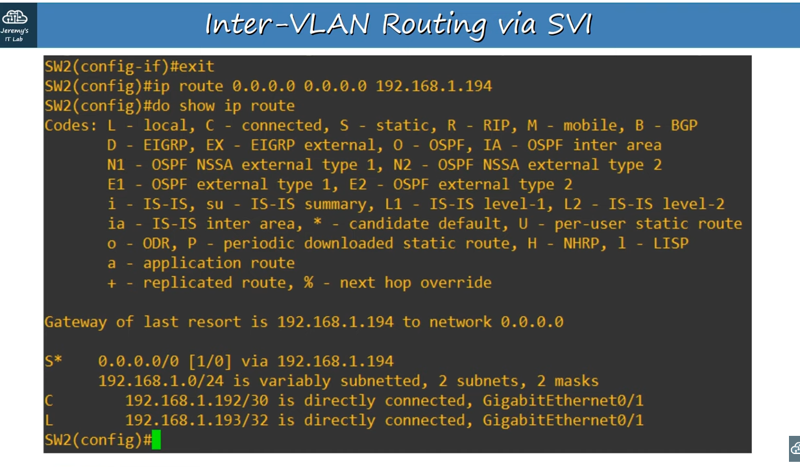
Configuring default route pointing to R1

Note: ‘default route’ is explained in previous lessons(lesson about static routes).

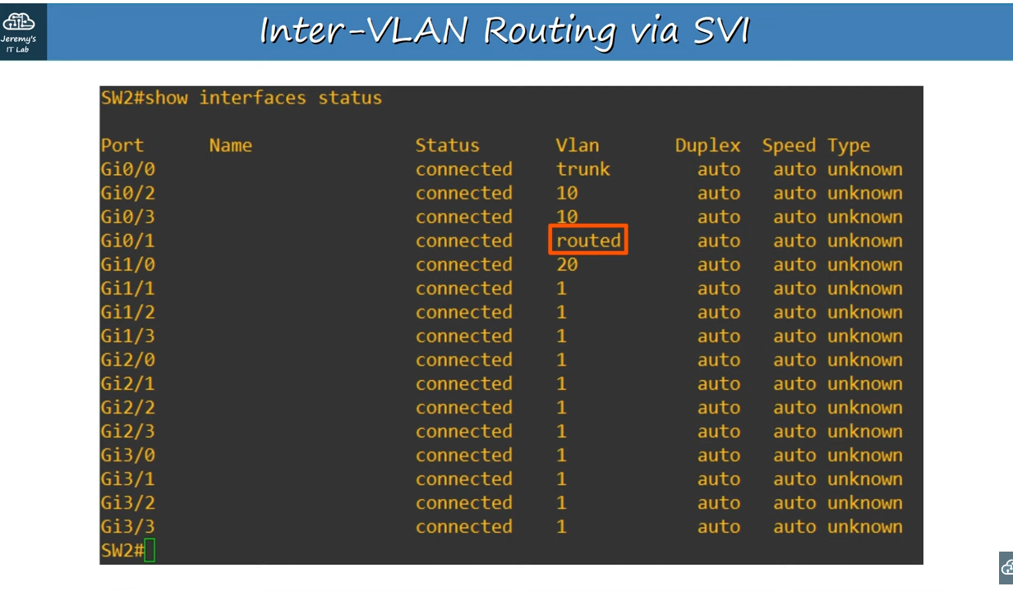
‘show interfaces status’ command

Note: We can also use this command to confirm.So here in ‘Vlan’ column it shows ‘routed’.

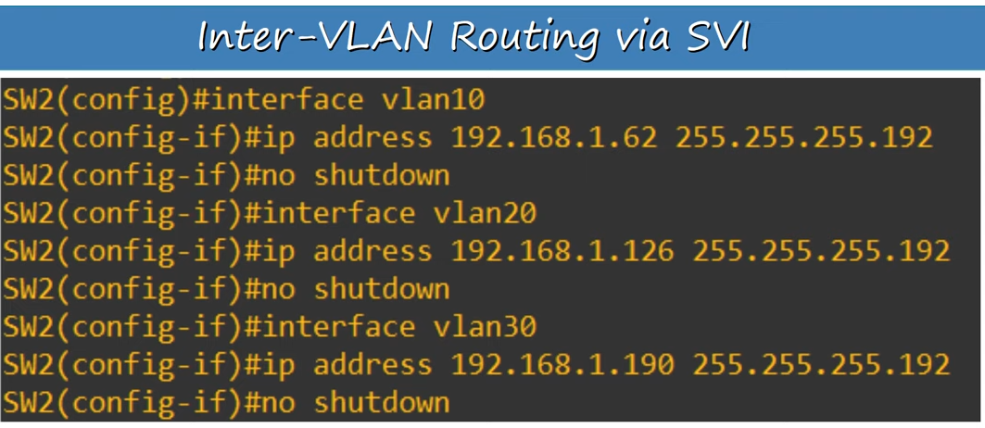
SVI configurations on SW2

Note:We use ‘inteface VLAN10’ ,for example, to create an SVI for VLAN10 and configure it.

Note: SVIs are shutdown by default,so we should use ‘no shutdown’ to enable them.

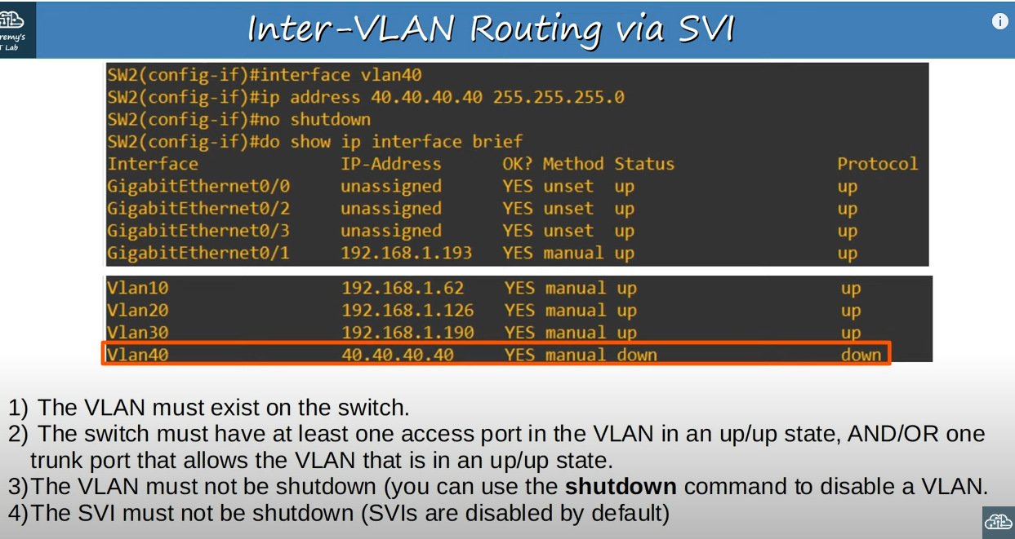
About problem that we might encounter

Note: We created another SVI for a VLAN that doesn’t exist on the switch and assigned IP address to it .We also enabled it.However SVI itself is down/down.It’s because VLAN doesn’t exist on a switch.

Note: There are 4 requirements on image for an SVI to be up/up.

Note: (continuing first requirement) When we assign an access port to a VLAN,if the VLAN doesn’t yet exist on the switch, the switch will automatically create the VLAN. However if we create an SVI for a VLAN that doesn’t exist yet,the switch will not automatically create the VLAN.

Note: (in addition to second point)
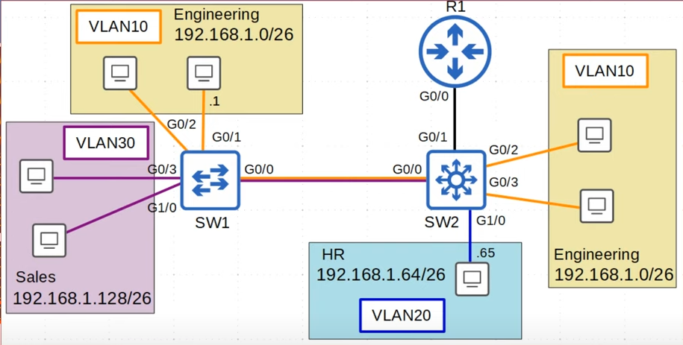
(in addition to second point)

Note: For example in this network topology SW2 has hosts connected in VLAN10 and VLAN20,so their SVIs can go up.There are no connected hosts in VLAN30,however it has a trunk port,G0/0,which allows VLAN 30 over it,so VLAN30’s SVI is up as well.

Note: (in addition to third point) This refers to VLAN itself,not the SVI.So VLAN must not be shutdown.We can enter VLAN configuration mode and enable the VLAN with ‘no shutdown’ command .

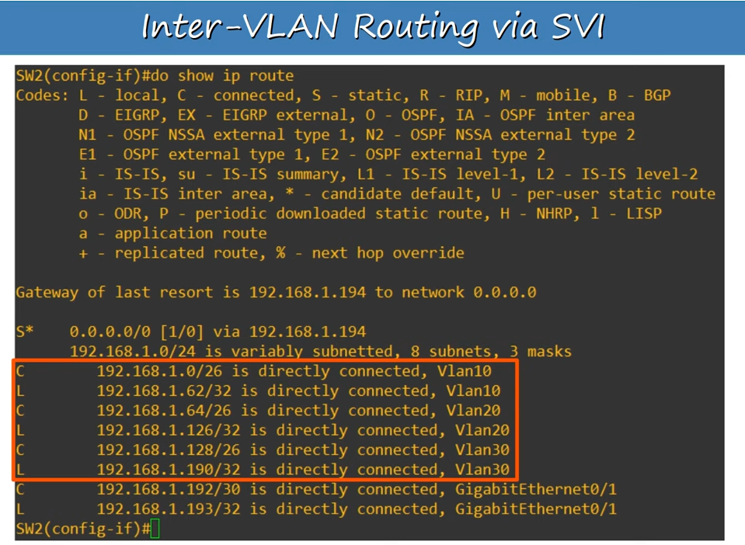
‘show ip route’ command output

Note: Here we can see local and connected routes have been added to the route table for the SVIs we have created.

Finally if PC wants to send traffic outside of the LAN it will send it to SW2,and SW2 will forward it to R1.R1 will take care of the traffic we sent.If one of our PCs wants to reach a destination in the LAN but in a different subnet and VLAN,SW2 will do the inter-VLAN routing without having to send the traffic to R1.

From Lab
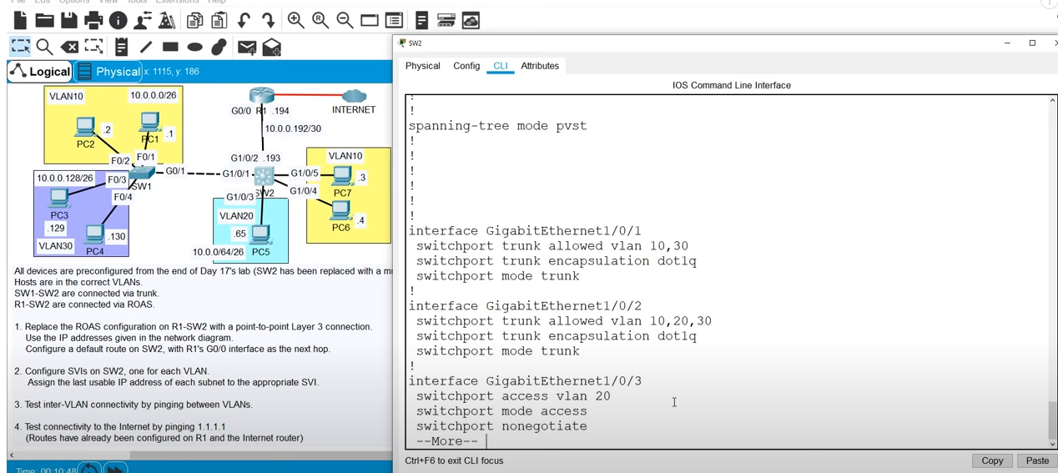
‘show running-config’ command output (part of SW2 interfaces)

Note: Layer 3 switch from lab requires ‘switchport trunk encapsulation dot1q’ command as we see from running configs.The model of switch used in this lecture previously did not require this command.

